

ADVANCED WEB ENGINEERING

Name: Bijay Jhengja Reshmi Magar

University ID: 77356811

Git Commit Screenshot

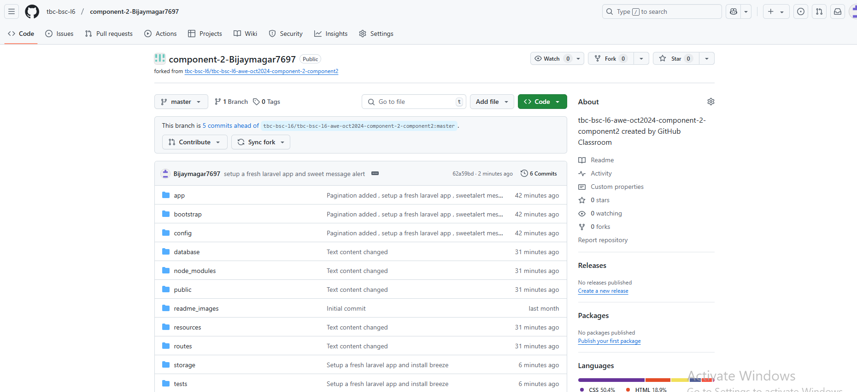

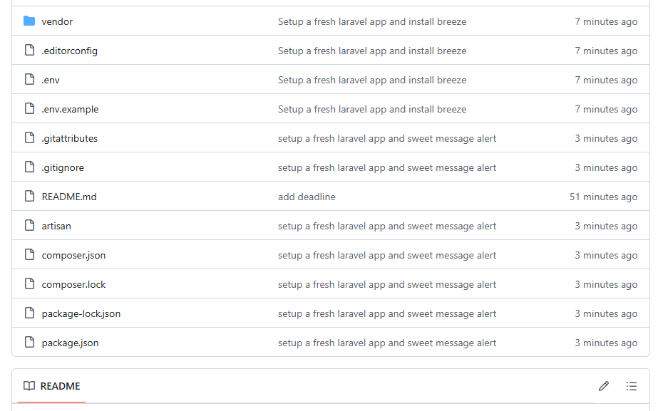

Repository link:  [https://github.com/tbc-bsc-l6/component-2-Bijaymagar7697](%20https://github.com/tbc-bsc-l6/component-2-Bijaymagar7697)

Youtube link:  [https://www.youtube.com/watch?app=desktop&v=ihsuMs-A3rQ](%20https://www.youtube.com/watch?app=desktop&v=ihsuMs-A3rQ)

The Website

Website UI

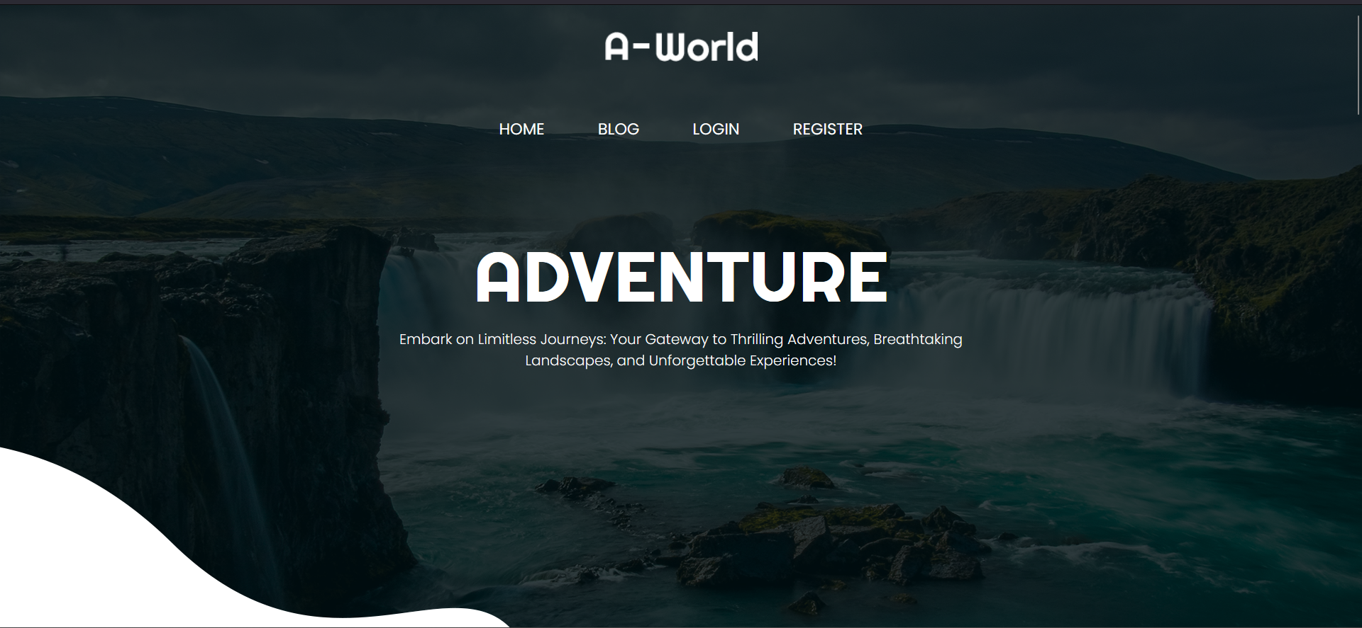

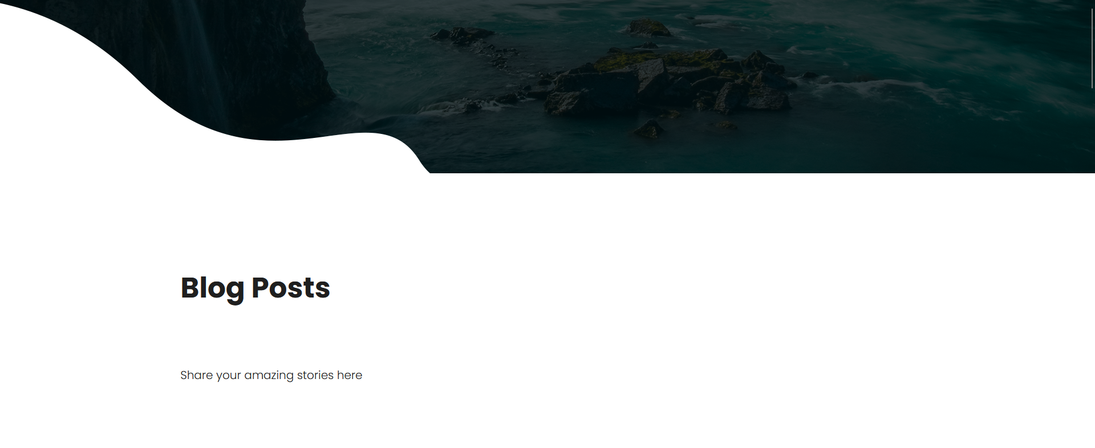

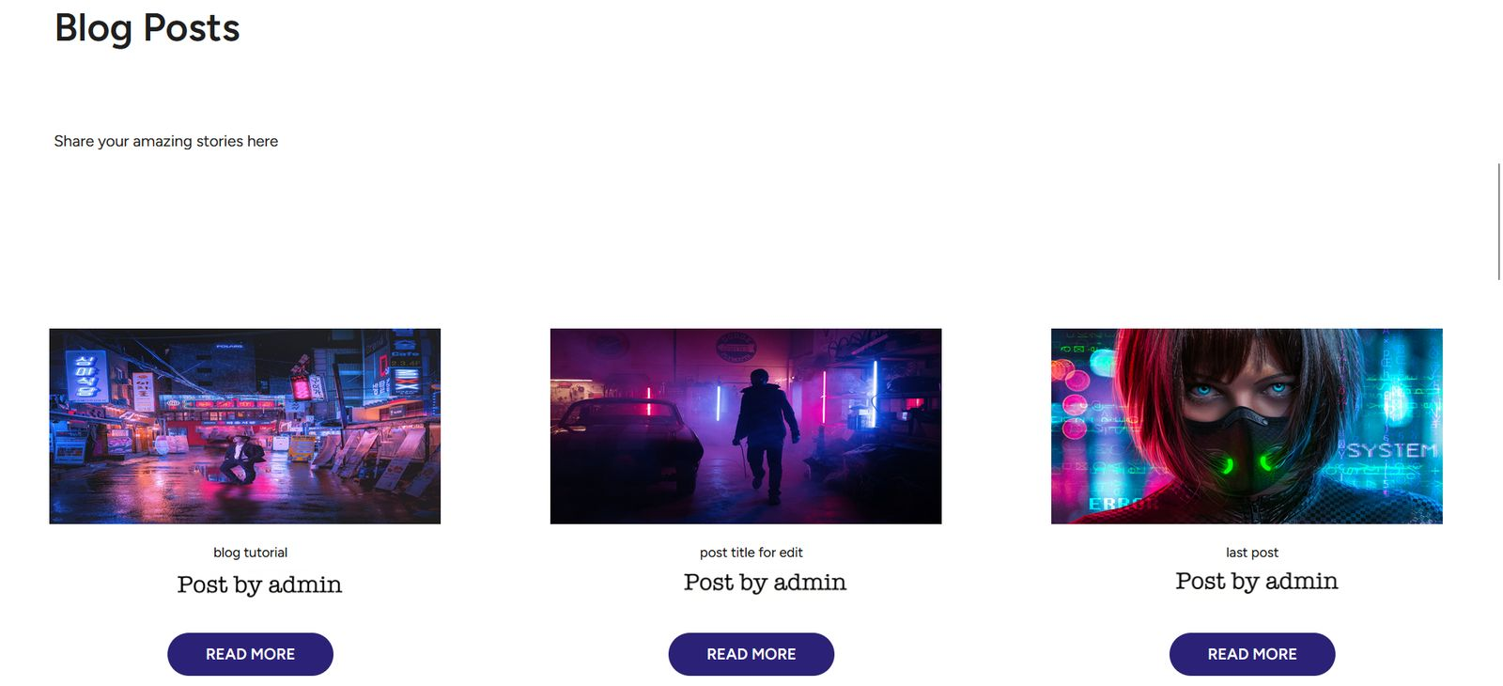

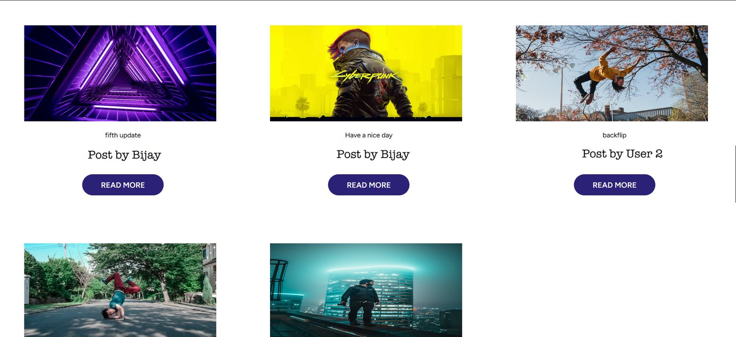

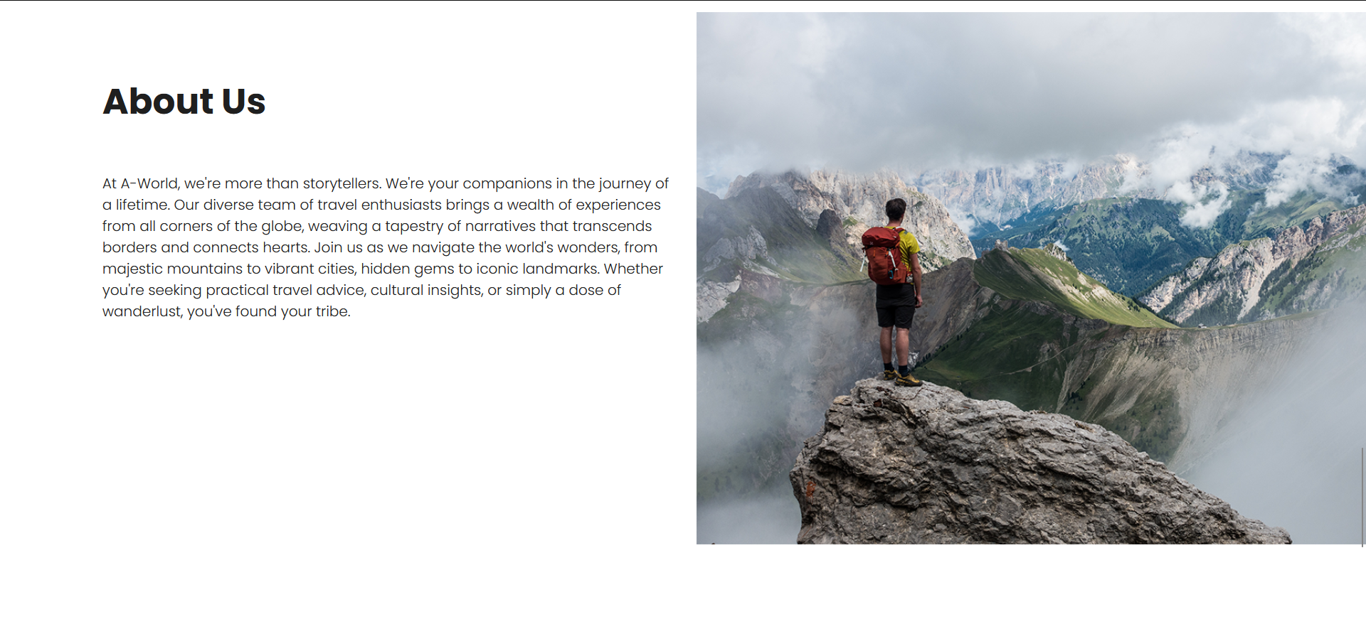

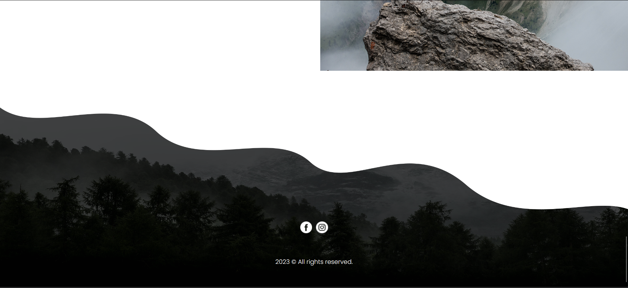

This is page that will be appear when user clicks on the website link. It has a header section with four links: Home, Blog, Login and Register.

Register Page

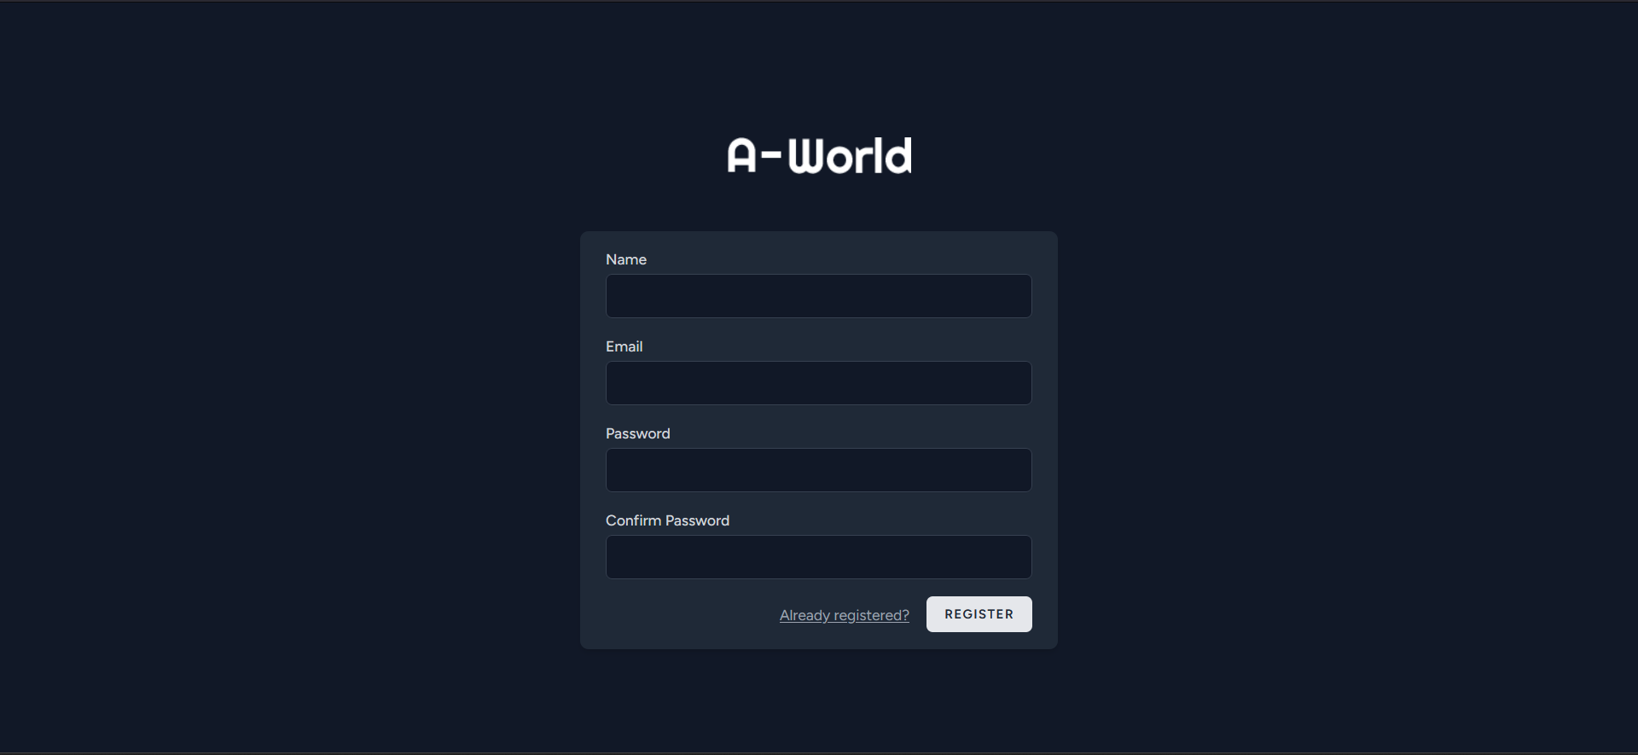

This is the register page interface where the user can register with name, email and password.

Login Page

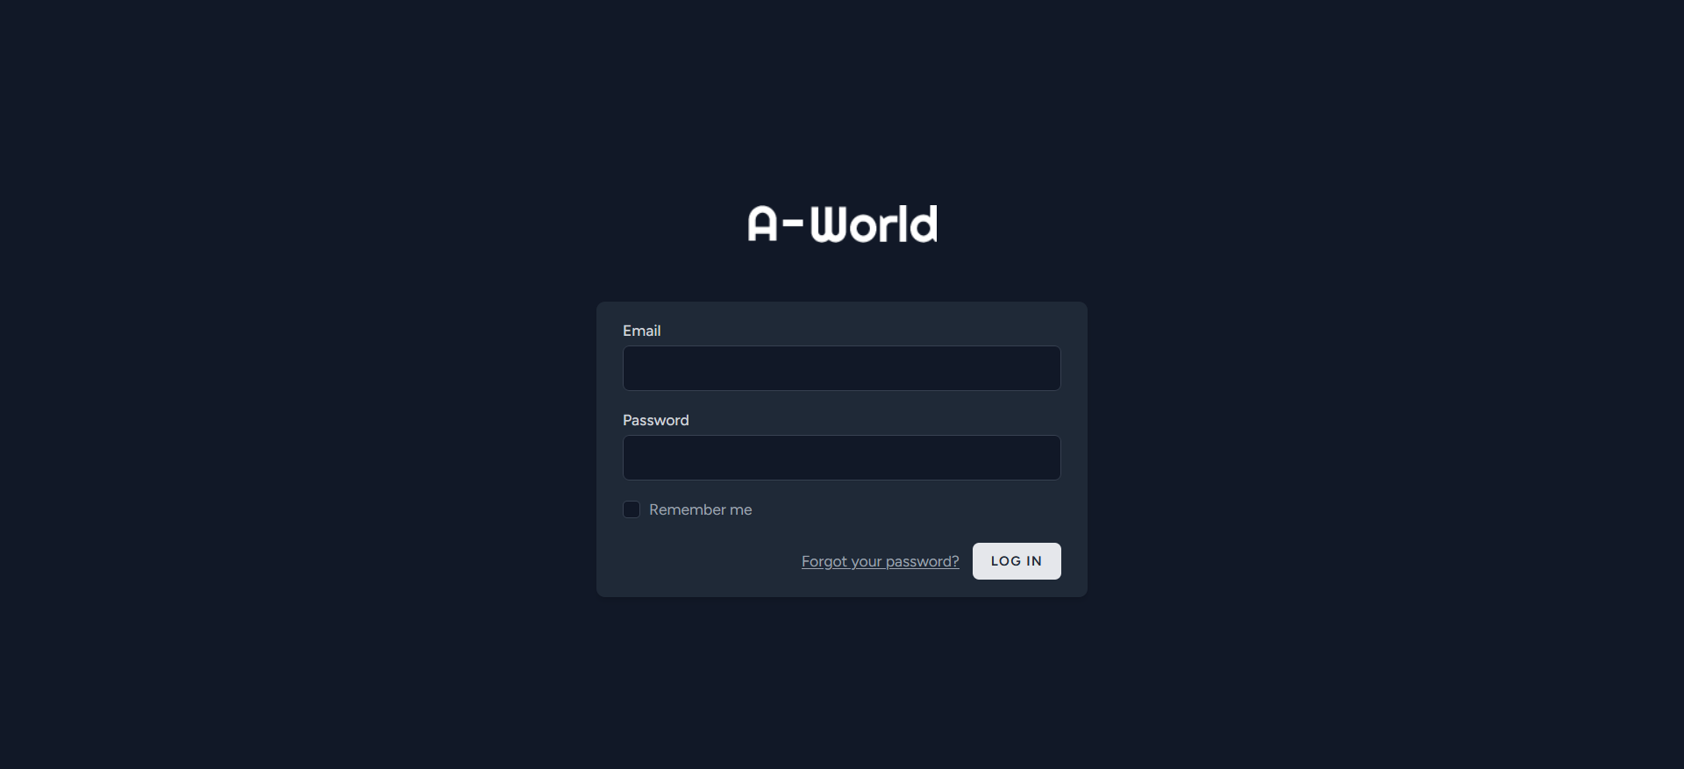

A registered user can login to their account by entering email id and password. There are two types of users: normal user and admin. Both of them have their respective interfaces.

Normal User Interface

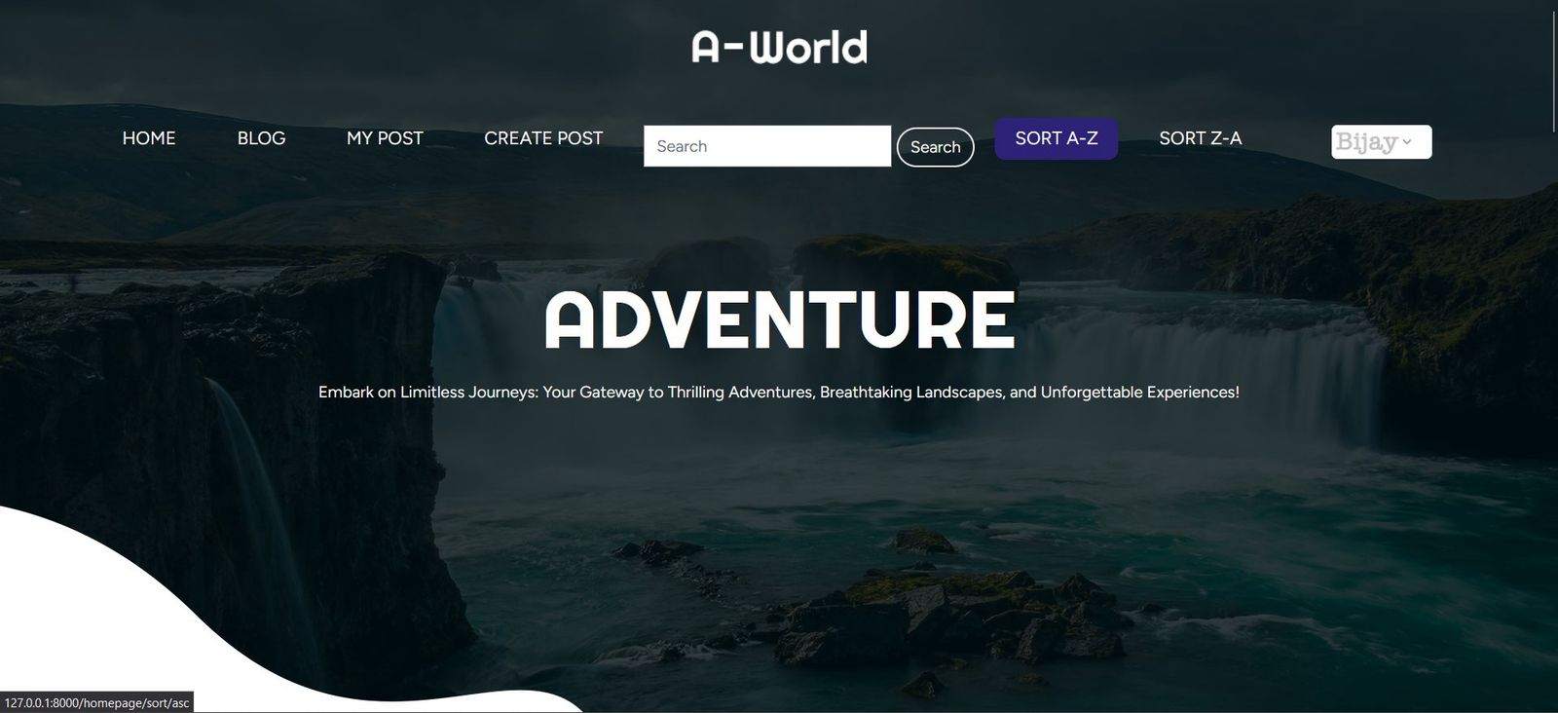

After a normal user logs in, this is the user interface that will appear. This is the home page. There are links to different pages in the website on the header section. They are HOME, BLOG, MY POST, CREATE POST, the search bar with search button, sorting links and logout button. The part below the header section is the banner. It has a background image with text on it.

HOME

Clicking on the HOME link or the logo at the top will redirect the user to the home page.

BLOG

Clicking on the BLOG link will send the user to this page:

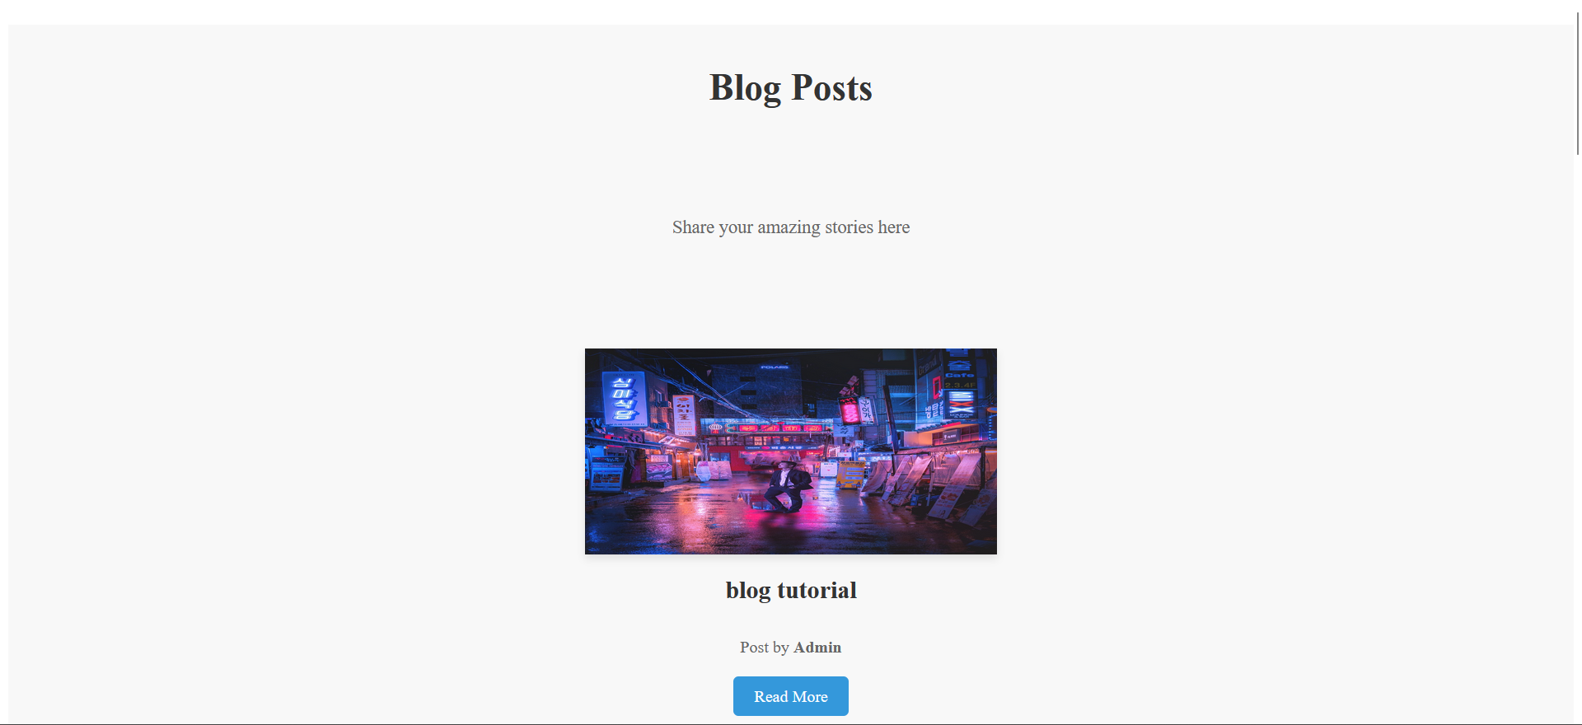

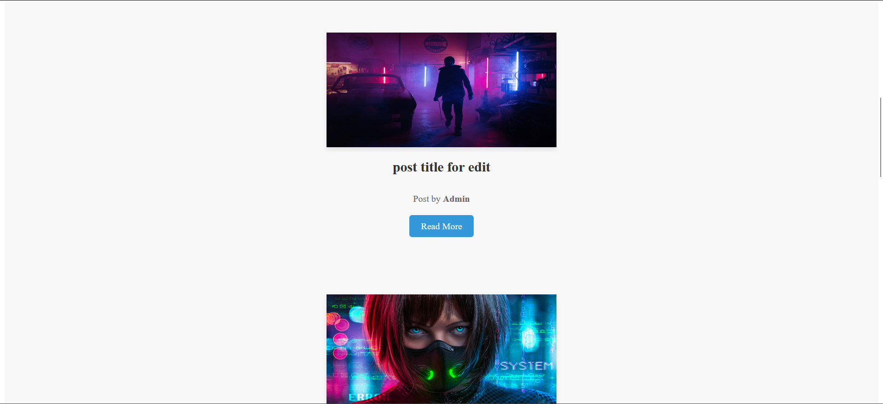

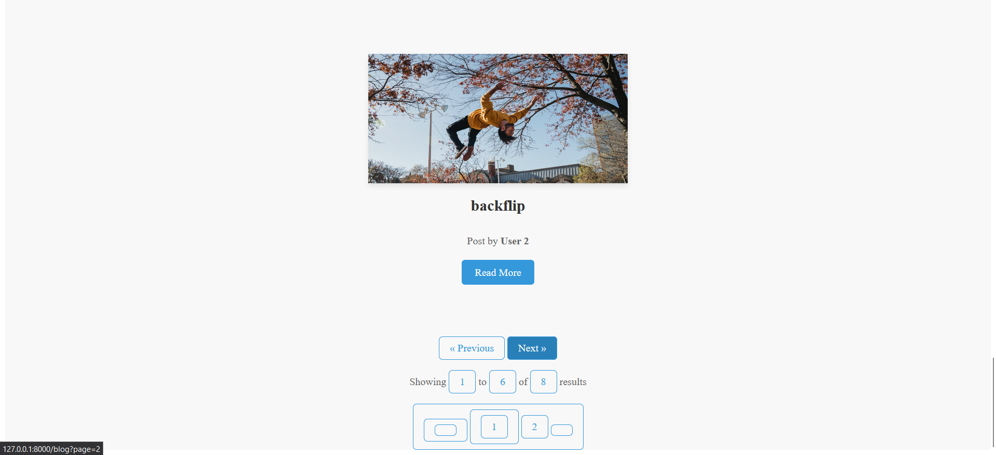

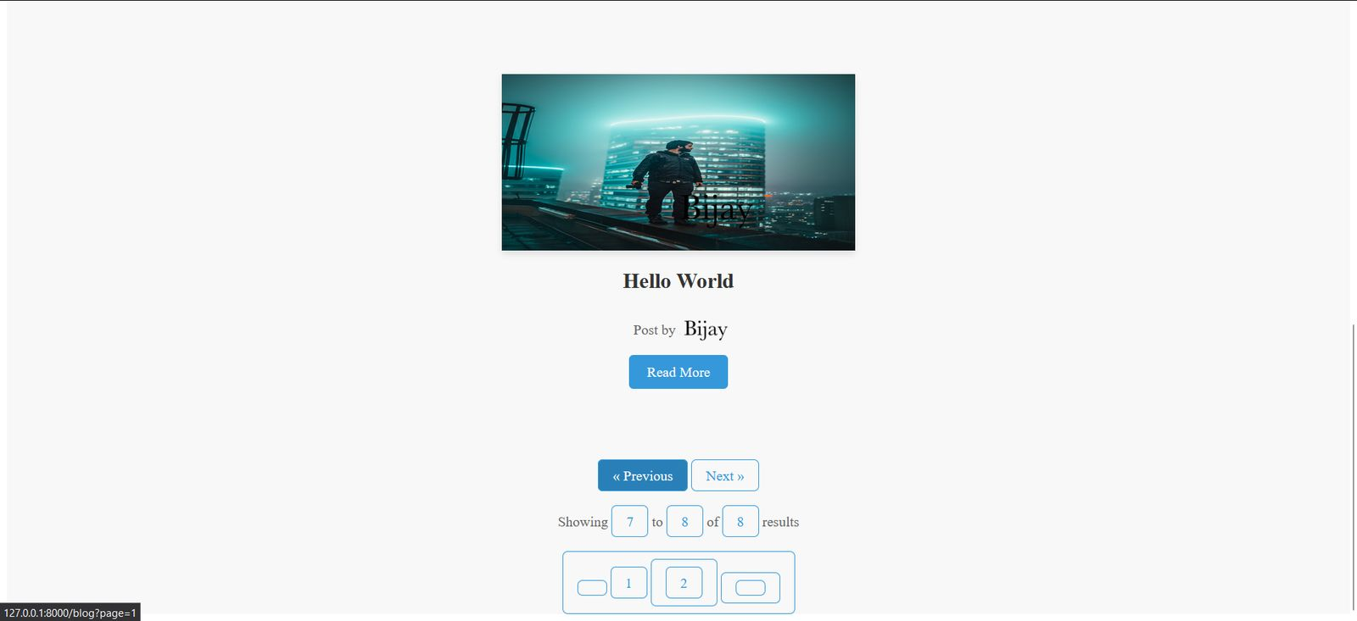

This page contains the pagination for the blog posts. User can go to the next page by clicking on the Next>> button and come back to the previous page by clicking the <<Previous button.

MY POST

This page displays the posts uploaded by the user that is currently logged in.

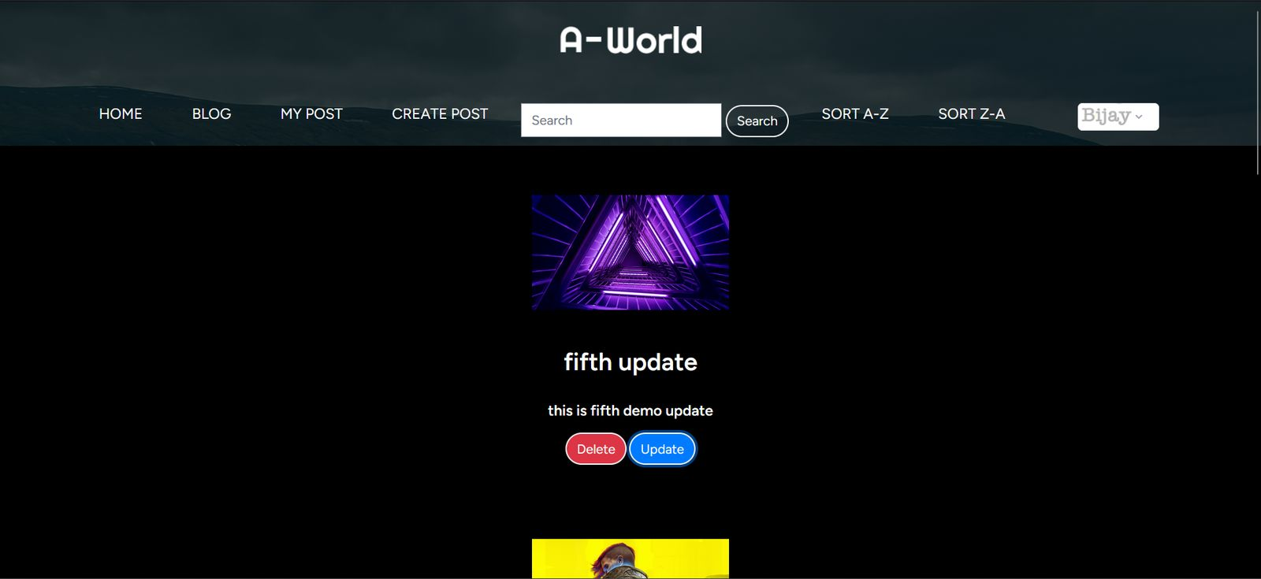

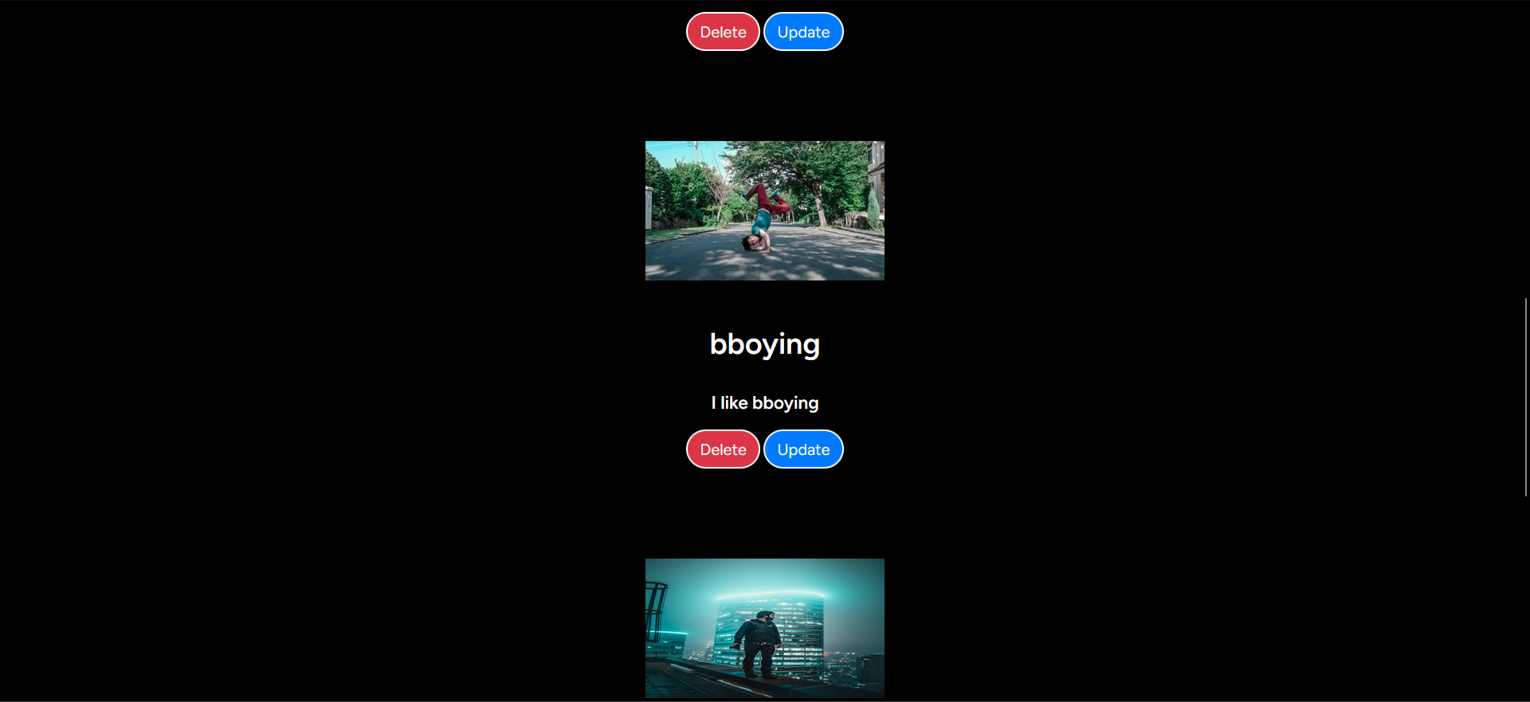

There are two buttons: Update and Delete.

The user can update his/her post by clicking the Update button.

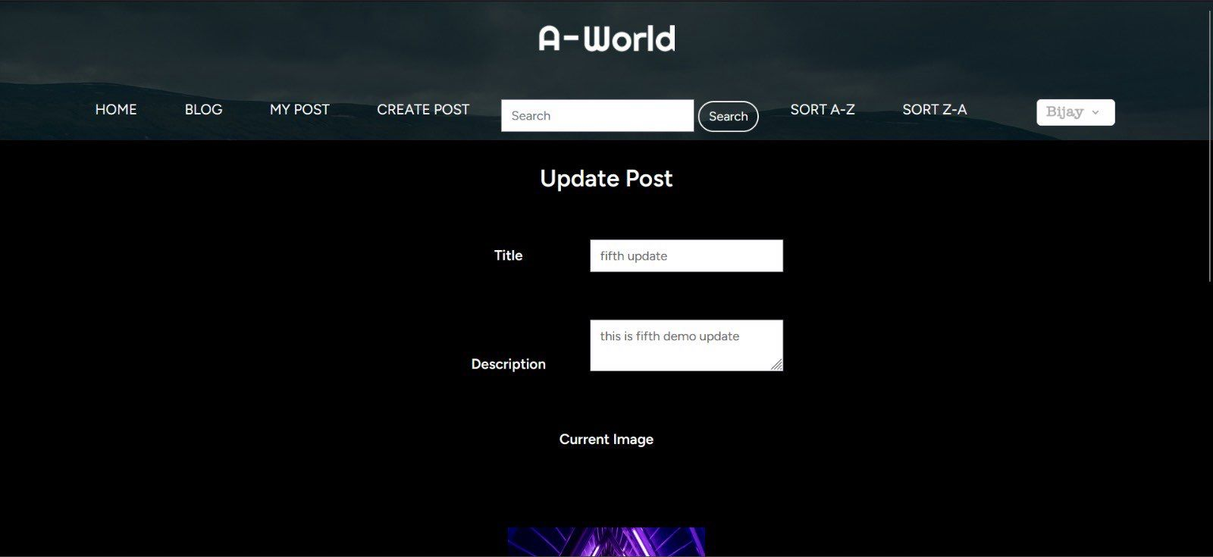

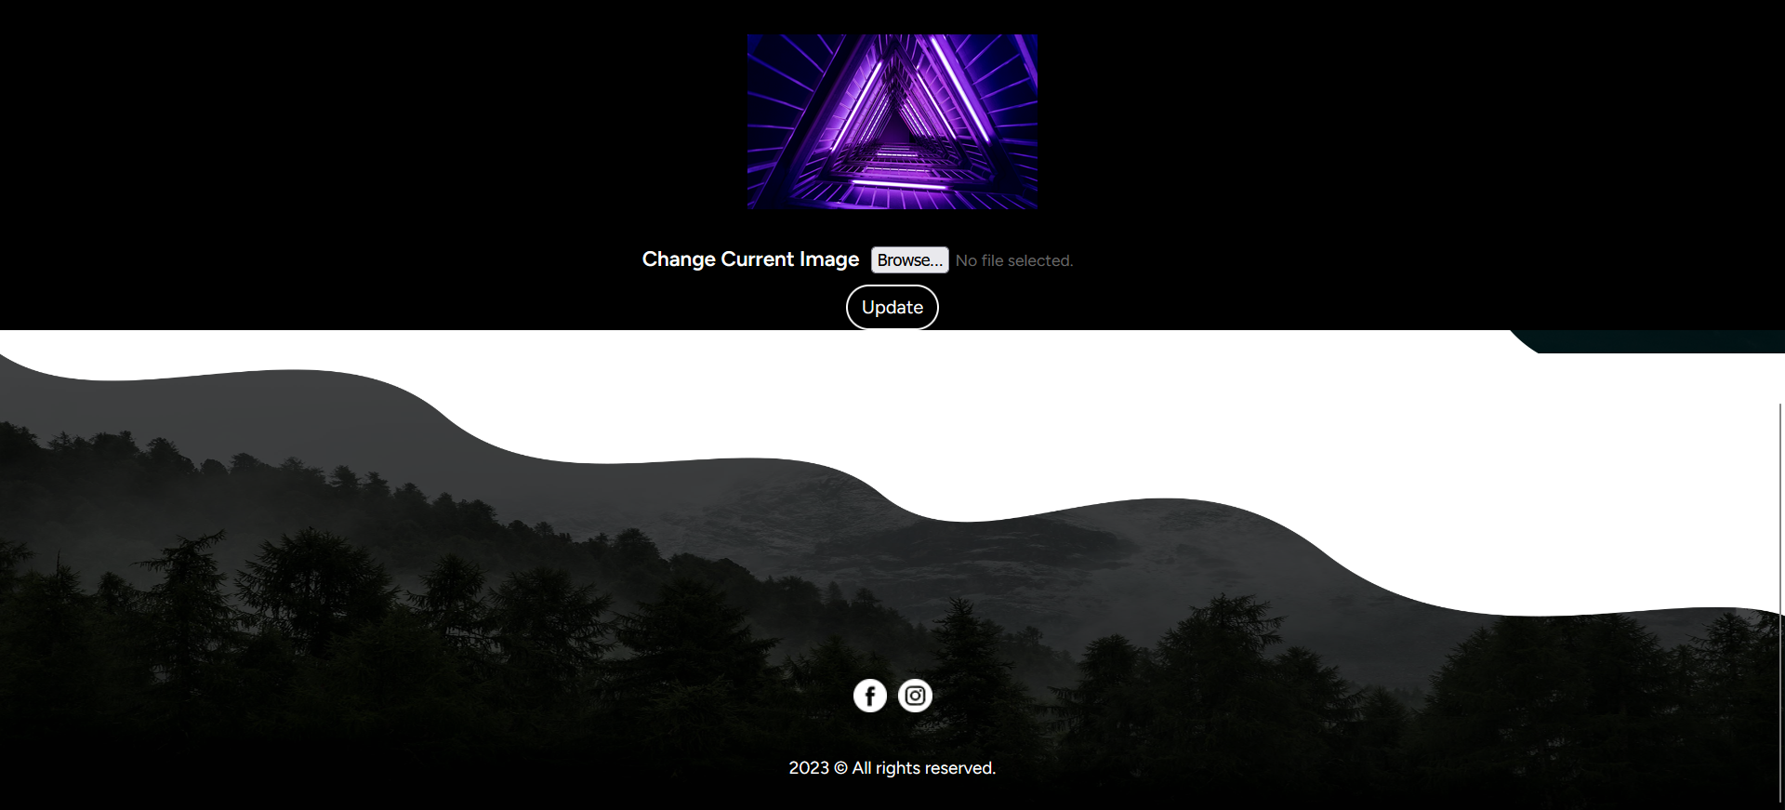

After clicking Update button, the user can update his/her post title, description image by uploading the data in the necessary fields and clicking the update button.

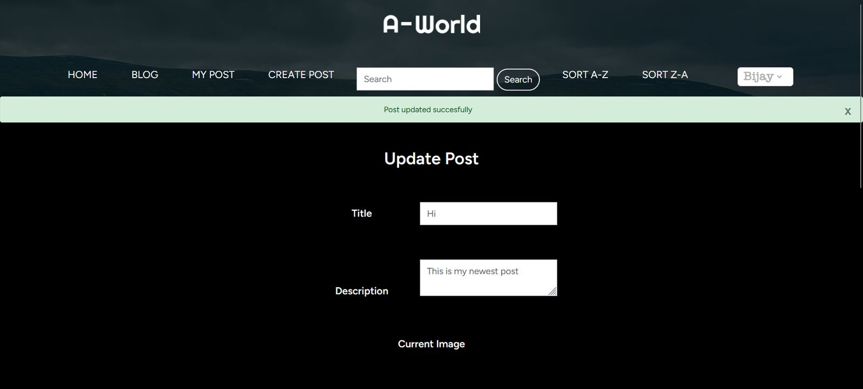

A message confirming that the post has been updated successfully will appear.



This user can also delete his/her posts by clicking the delete button.

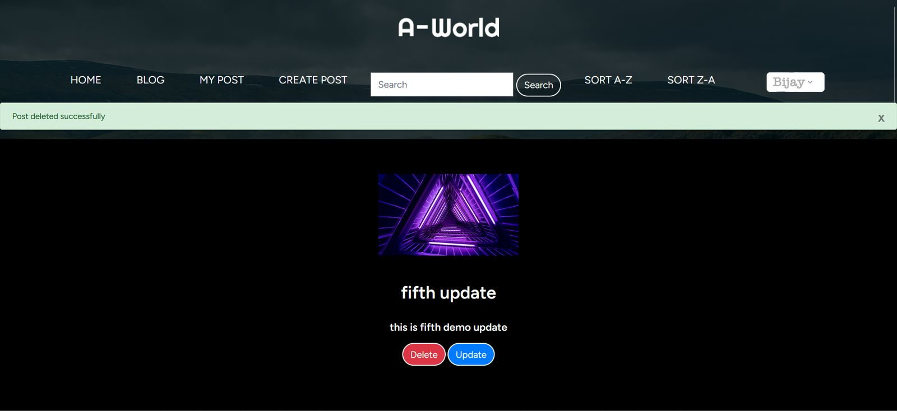

A message box confirming delete will appear.

CREATE POST

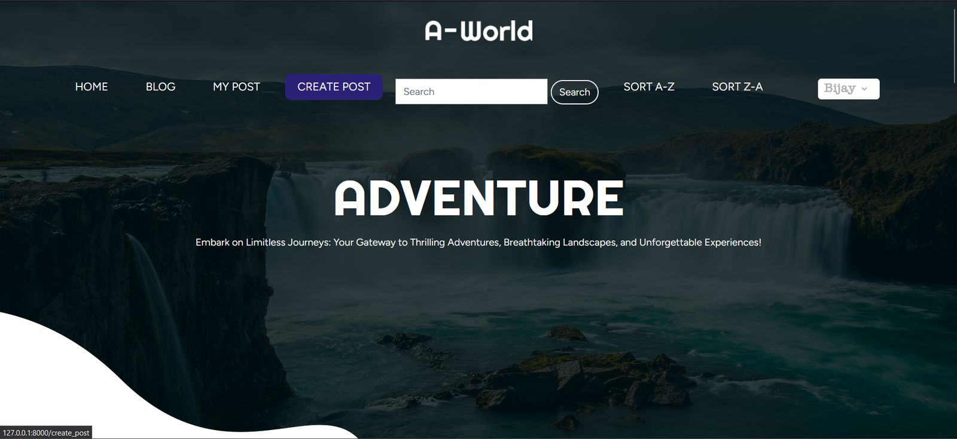

The user can add a new post by clicking on the CREATE POST link.

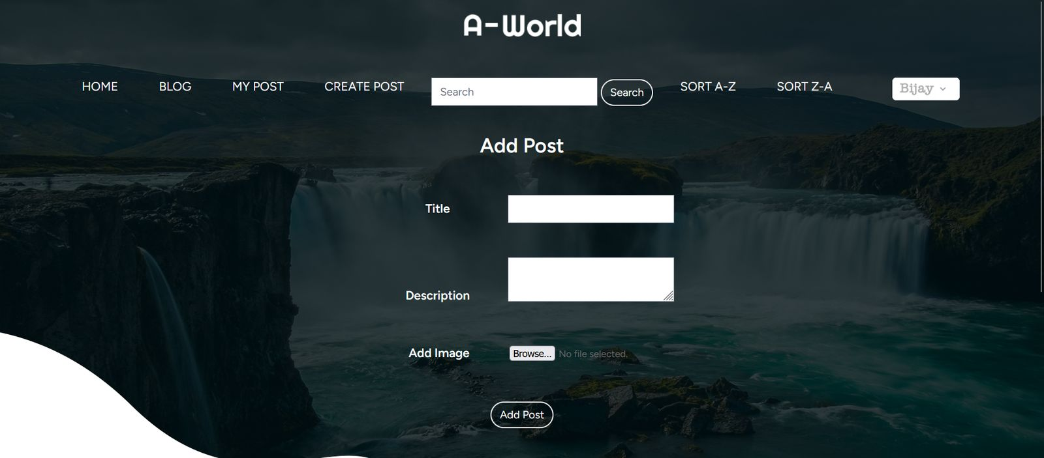

This is the page that will appear when user clicks the CREATE POST button. The user can add a new post by putting in the title, description and image and clicking the Add Post button.

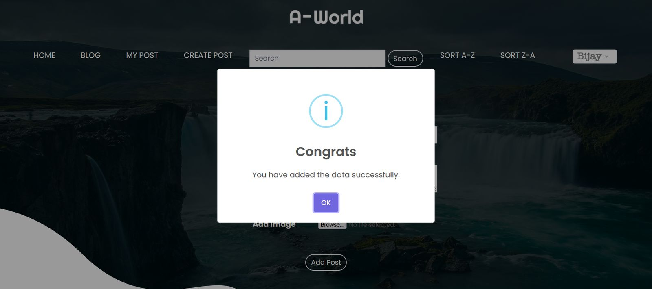

After adding a new post, a message box will appear confirming that the post has been added successfully.

Blog Posts section





This is the Blog Posts section below the banner of the page. The user can view the posts uploaded by himself/herself or by others if the post is approved by admin. The user can view the details about a post by clicking the READ MORE button.

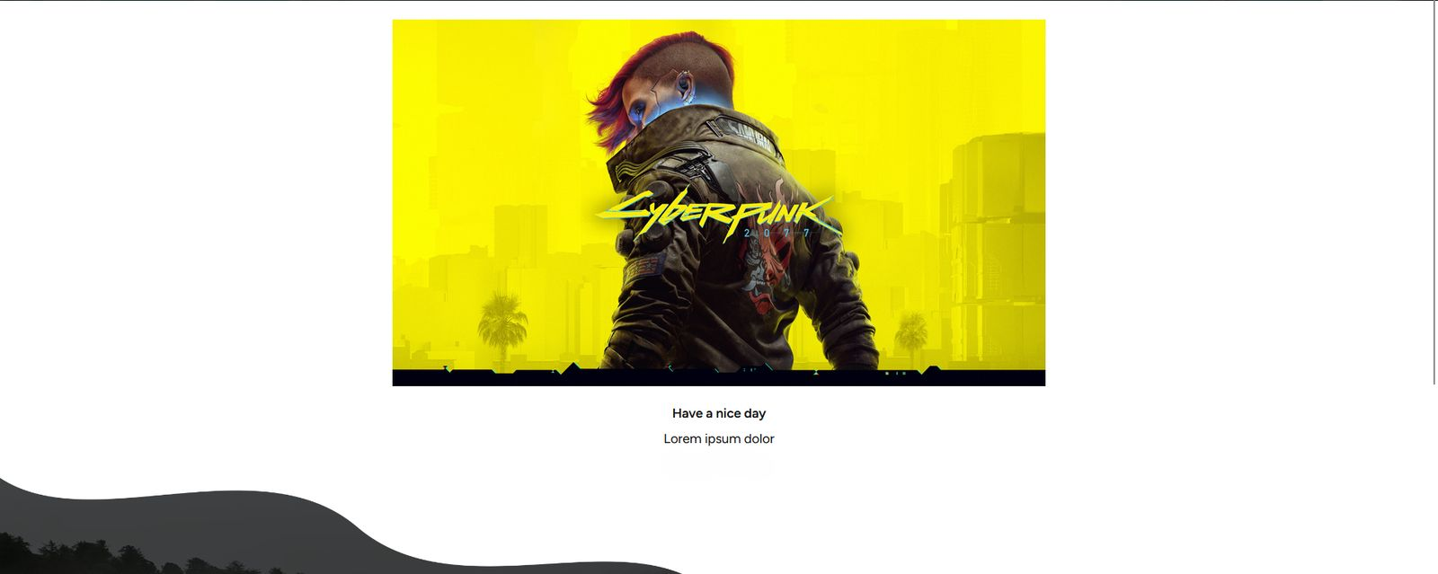

This is the post details page that appears when the user clicks the READ MORE button. It displays the post title, description and whom it was posted by.

On the header section, we have a search bar.

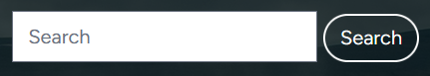

The user can search for a particular post by the post title or description of the post and clicking the Search button.

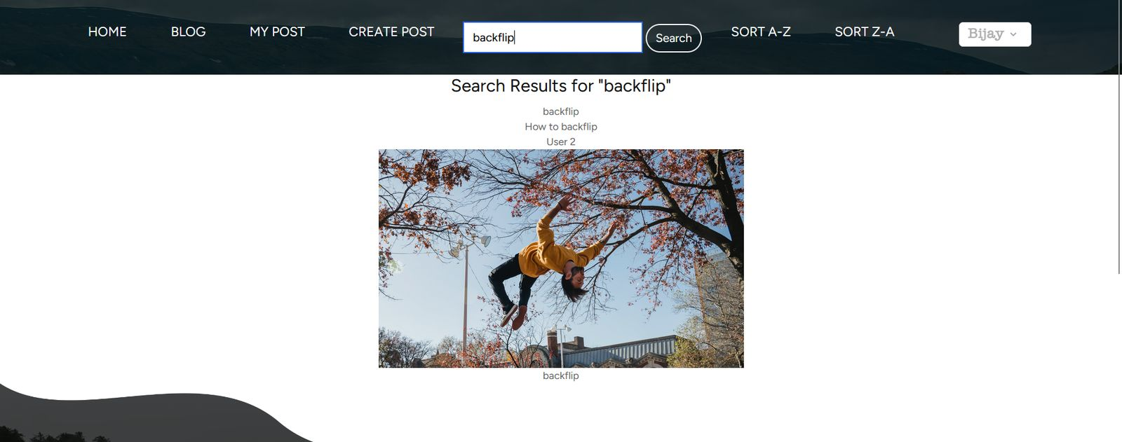

The header section has two more links which are the sorting links.

SORT A-Z



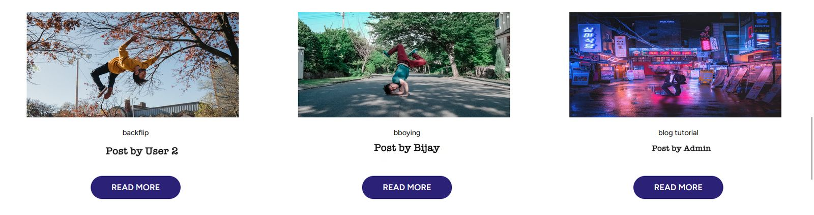

This link sorts the posts alphabetically based on their title in ascending order.

SORT Z-A

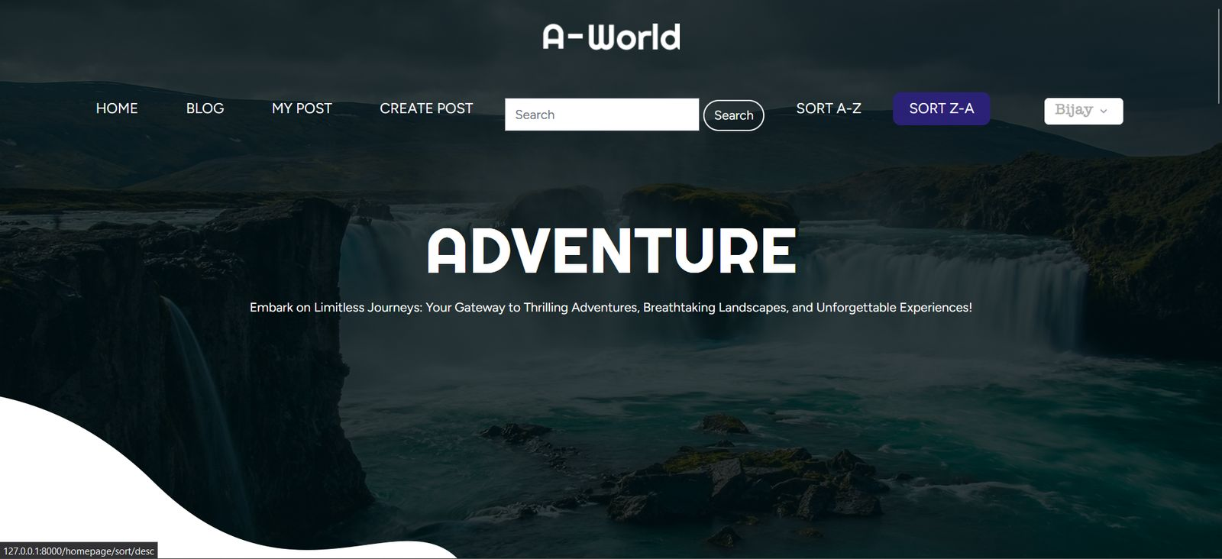

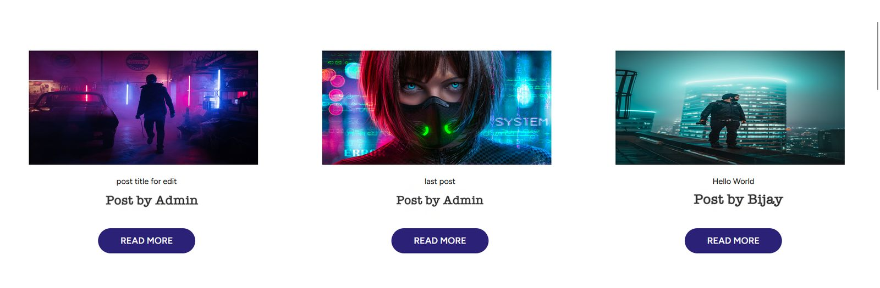

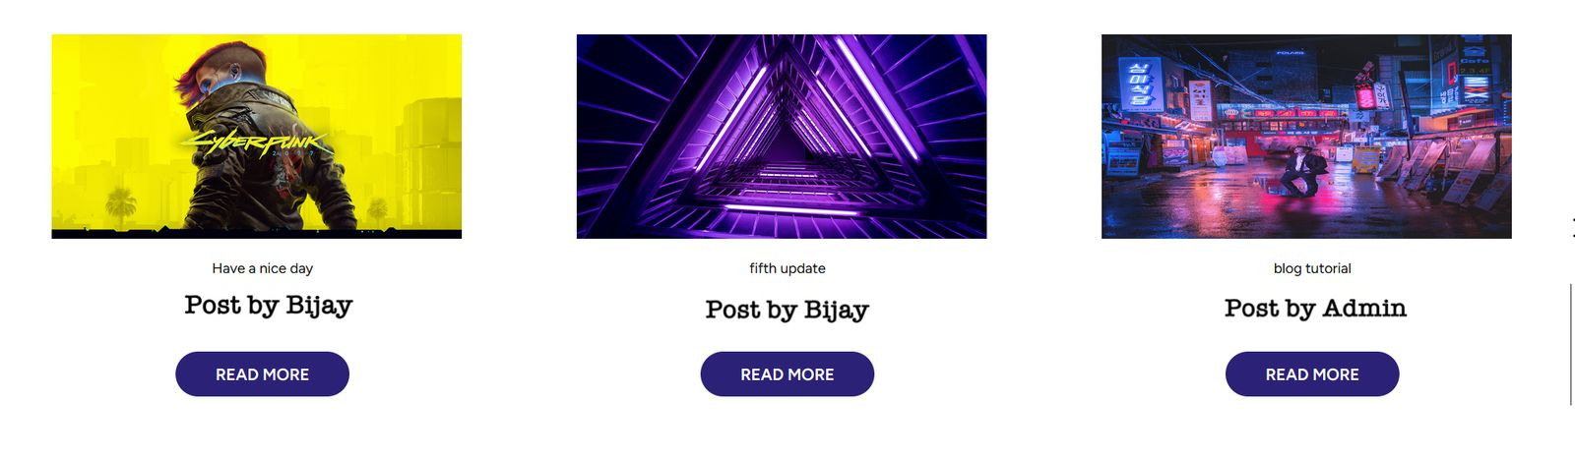

This link sorts the posts alphabetically in descending order.

About Us

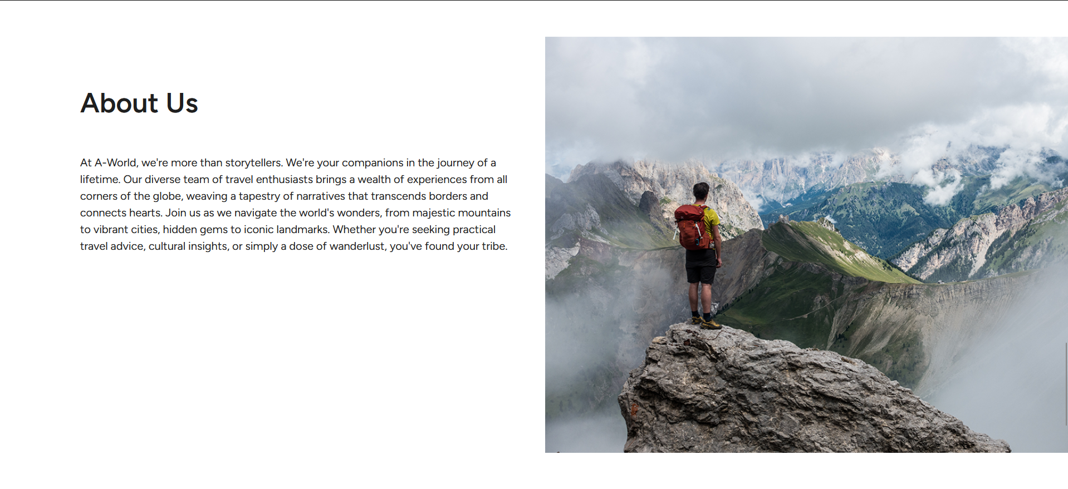

This is the about us section.

Footer section

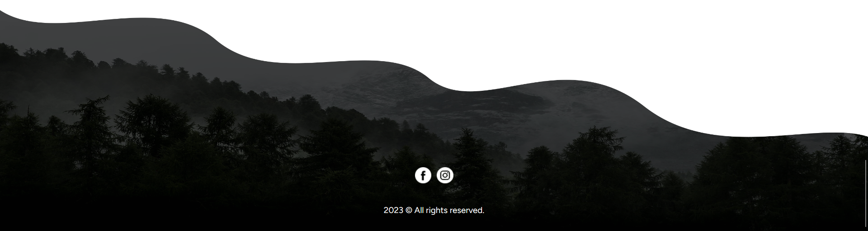

This is the footer section. It has two links at the bottom which are the links for Facebook and Instagram respectively. Clicking these links will redirect the user to the Facebook and Instagram profiles of the developer of this website.

Logout button

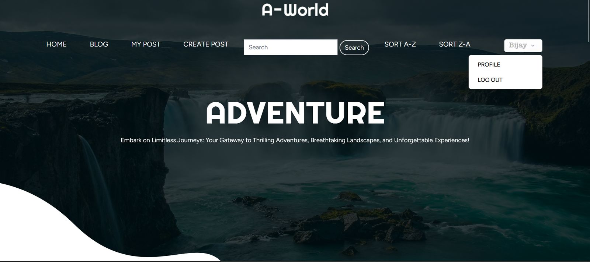

The logout button is like a drop down style button that consists of PROFILE and LOG OUT options.

PROFILE

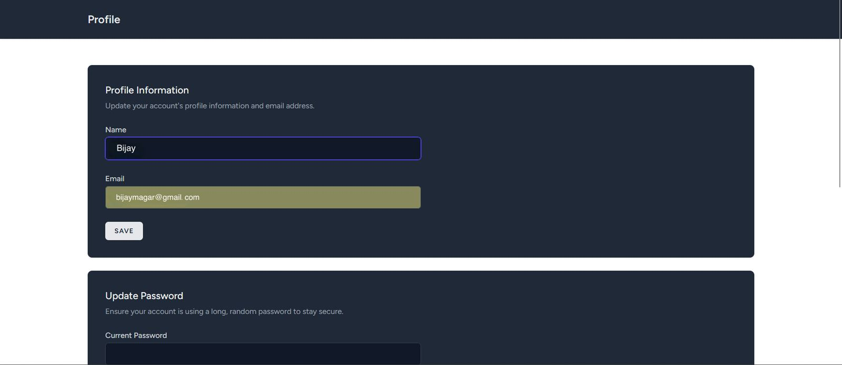

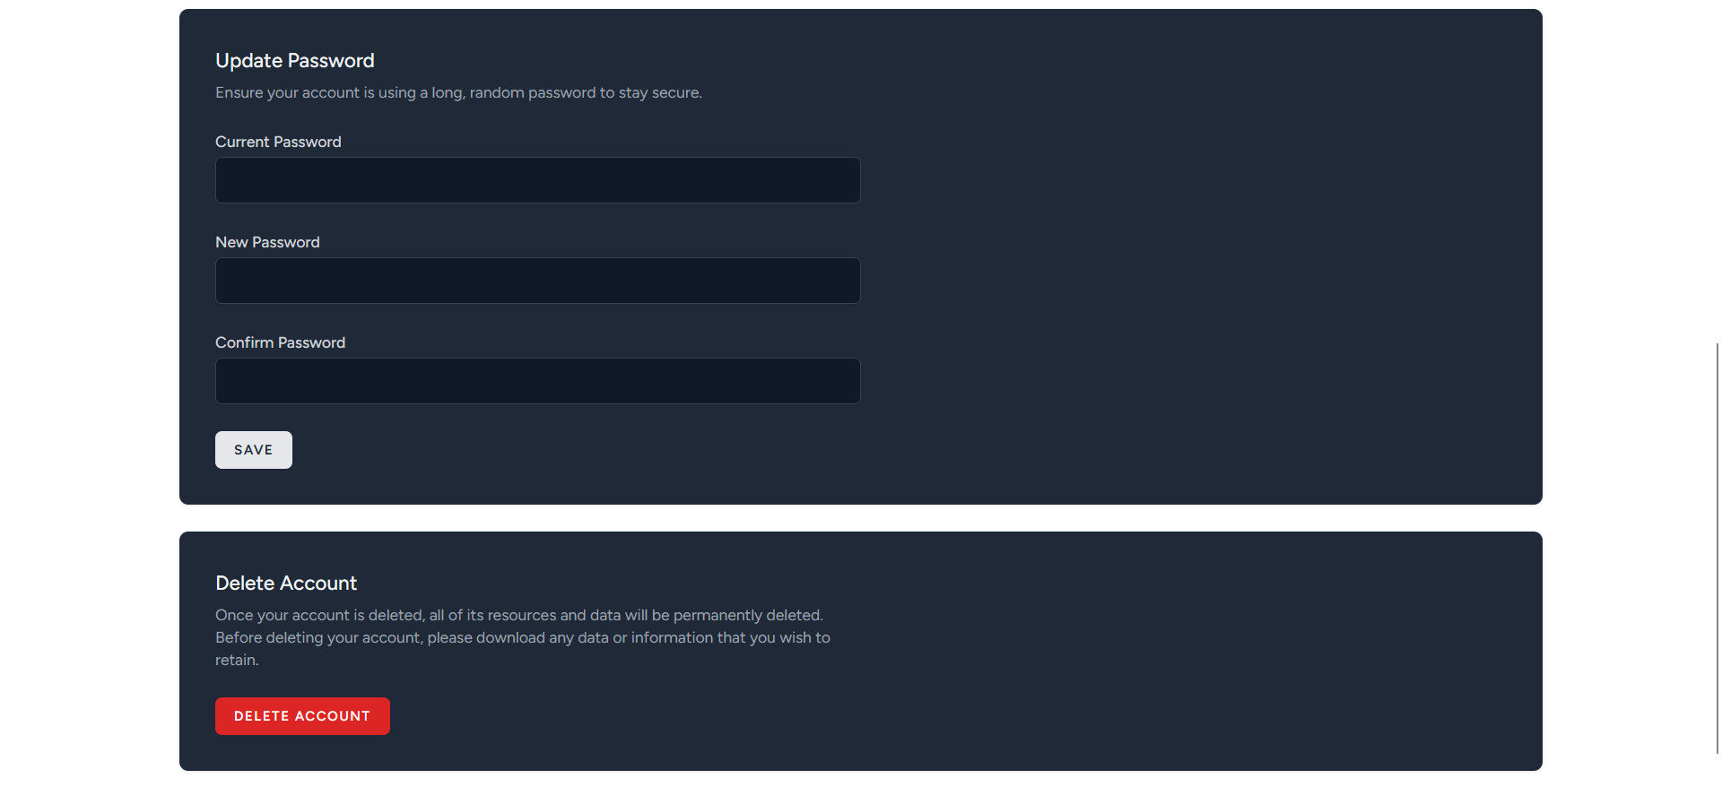

PROFILE on click redirects us to this page that enables a user to update his/her profile i.e. name, email id, password or delete account.

LOG OUT

The LOG OUT button logs a user out of his/her profile.

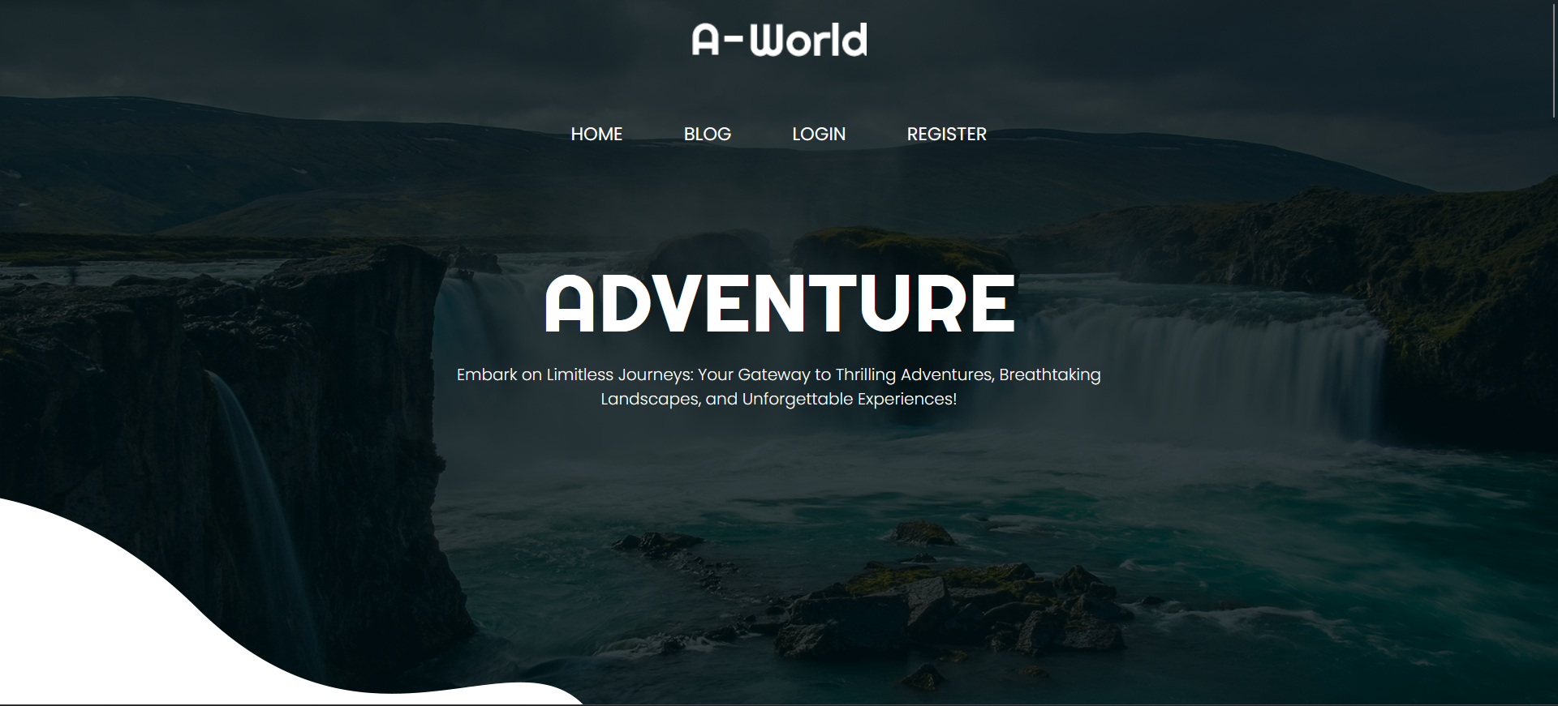

This is the page that will appear when user clicks LOG OUT.

Admin Interface

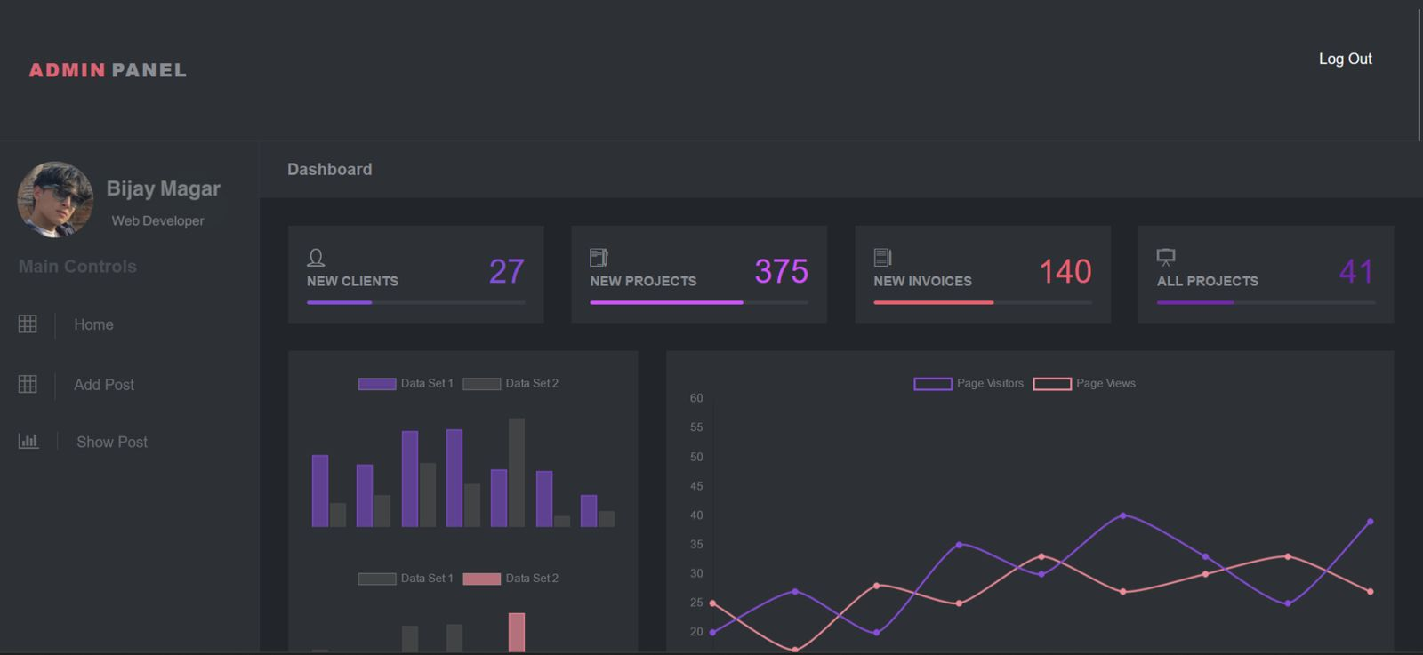

When an admin logs in, this is the user interface that will appear. This is the home page for admin dashboard. The header consists of the logo at the top left corner and the log out button at the top right corner. When the admin clicks on the logo, the admin will be redirected to the home page. Below the header section, we have a sidebar at the left side.

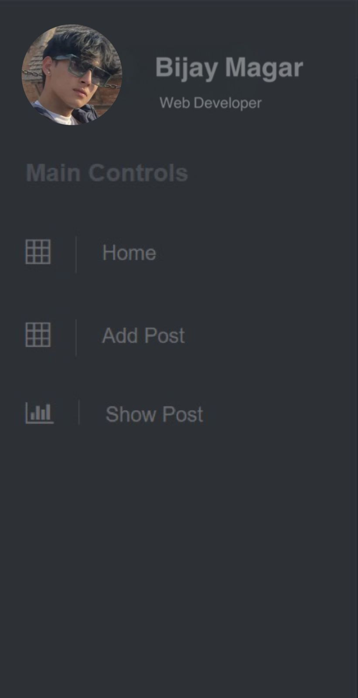

The sidebar contains a profile avatar of the admin with name. Below that, there is a section under the title Main Controls which have three links under it: Home, Add Post and Show Post.

Home

When the admin clicks on Home, the admin will be redirected to the admin home page.

Add Post

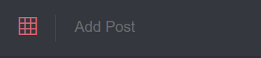

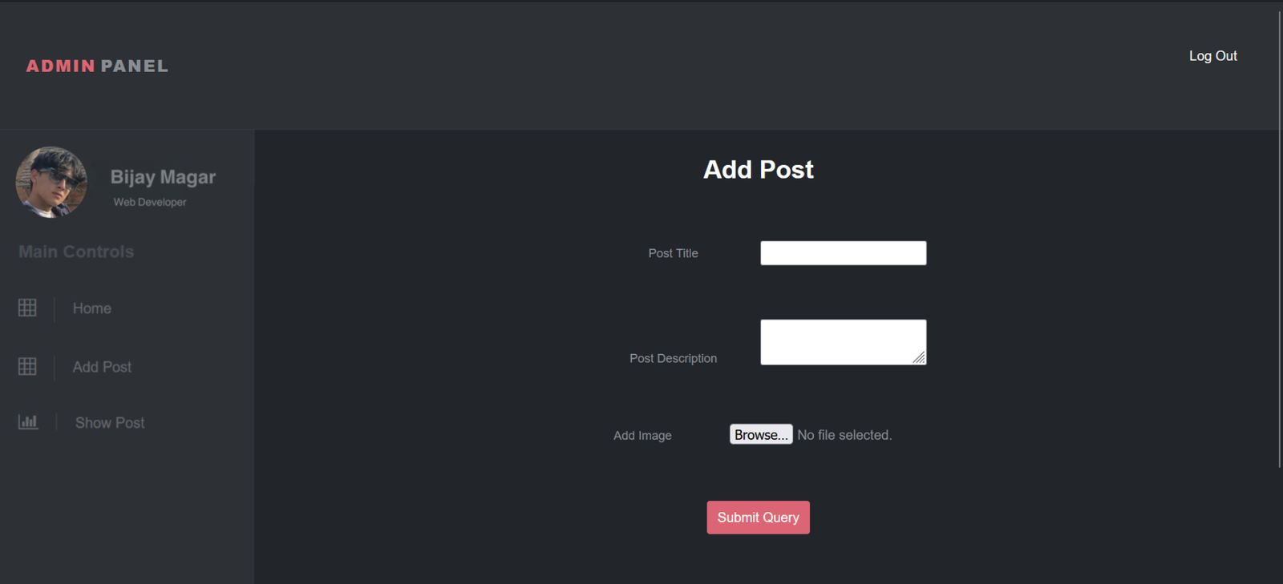

When admin clicks on Add Post, the admin will be redirected to this page. Here the admin can himself/herself add new posts by filling the title and description fields and uploading the image and clicking on the Submit Query button.

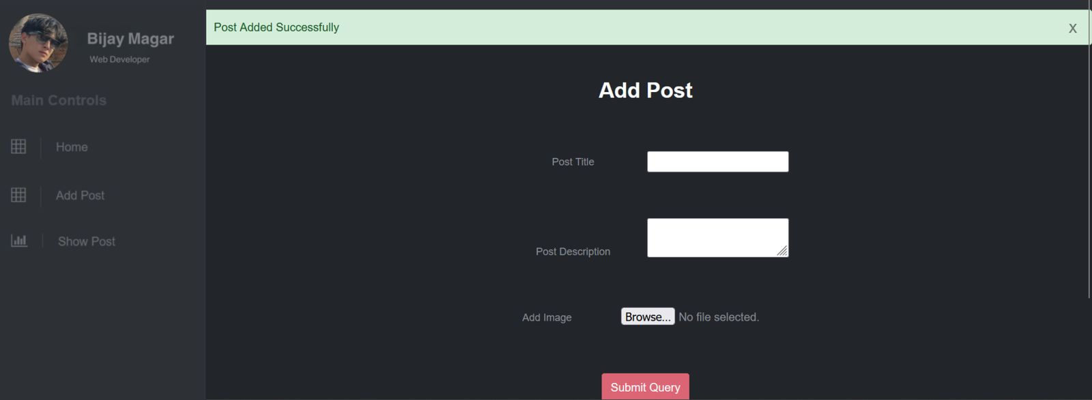

A message confirming post added successfully will appear at the top.

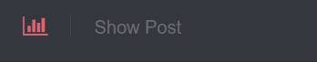

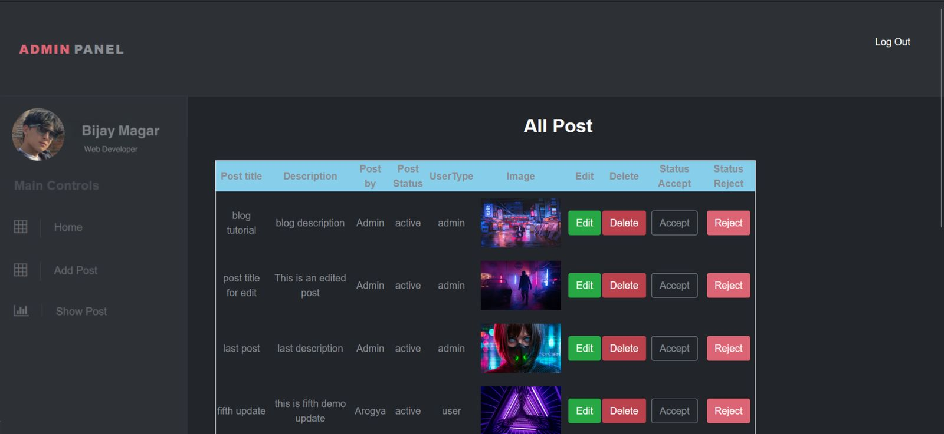

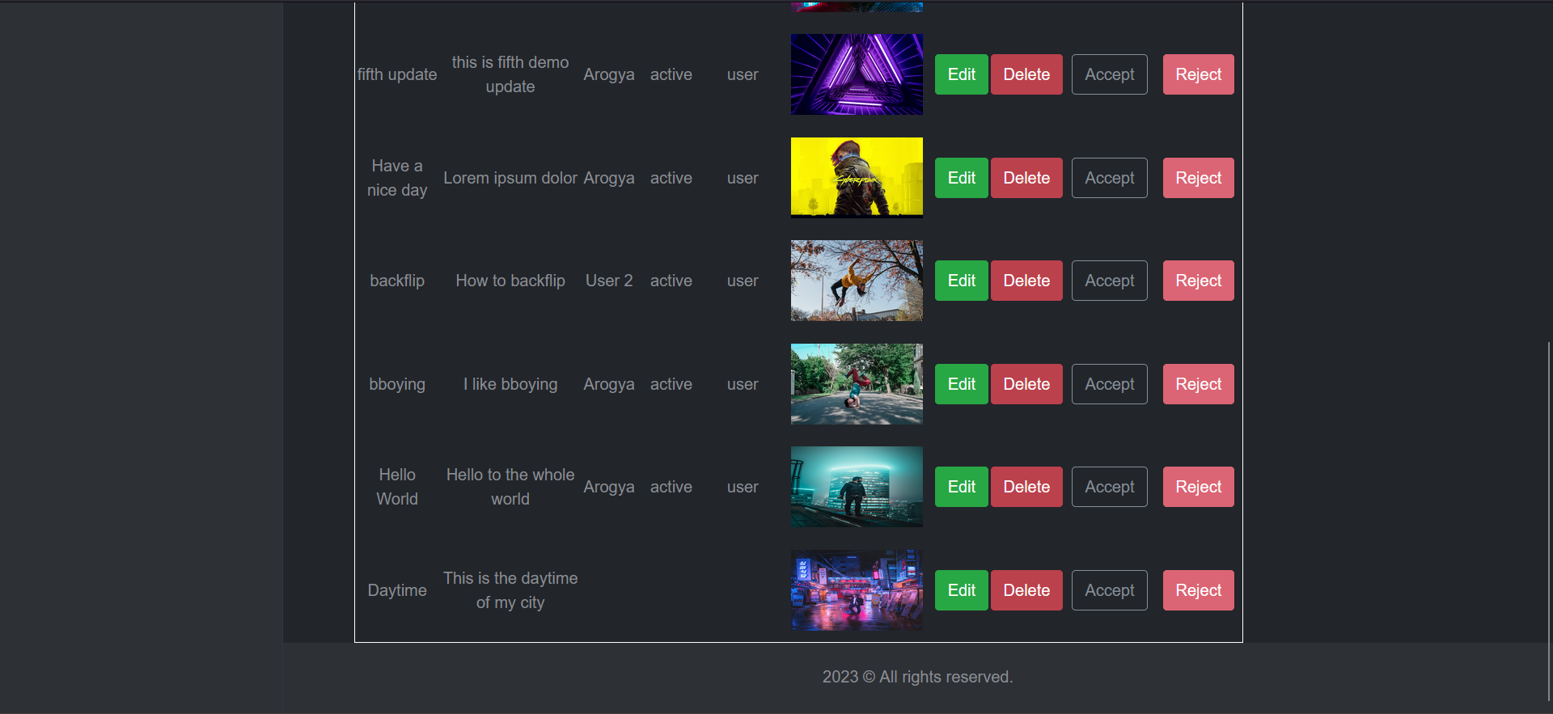

This is the page that will appear when the admin clicks on the Show Post link. Here, the admin can view his/her own posts and the posts of other users. Admin can edit posts by clicking on the Edit button.

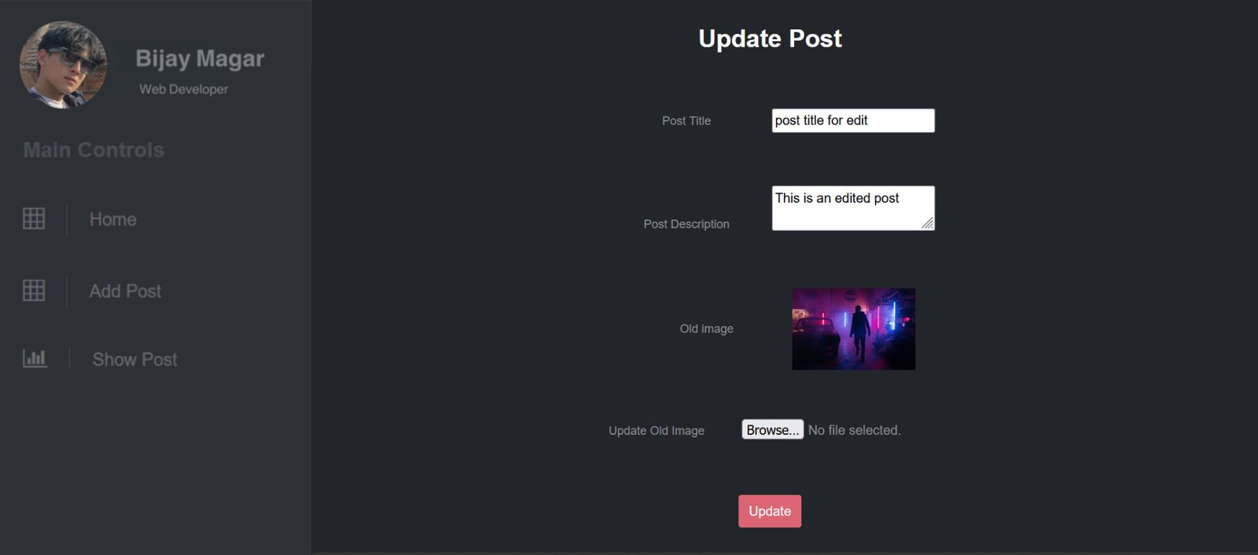

This is the page that will appear when admin clicks the Edit button. The admin can then update the fields and images and click the Update button.

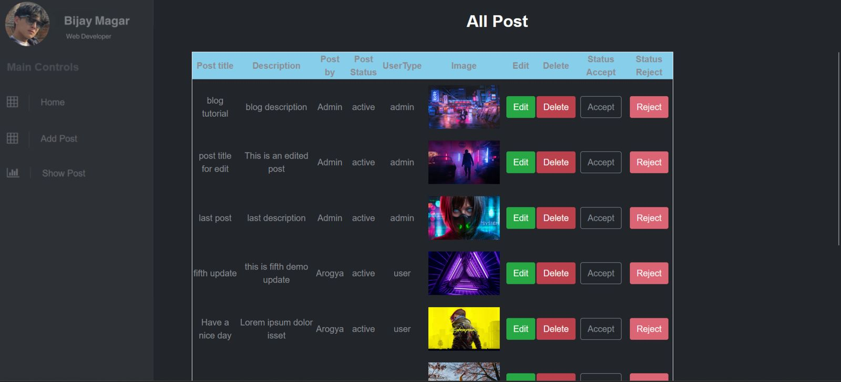

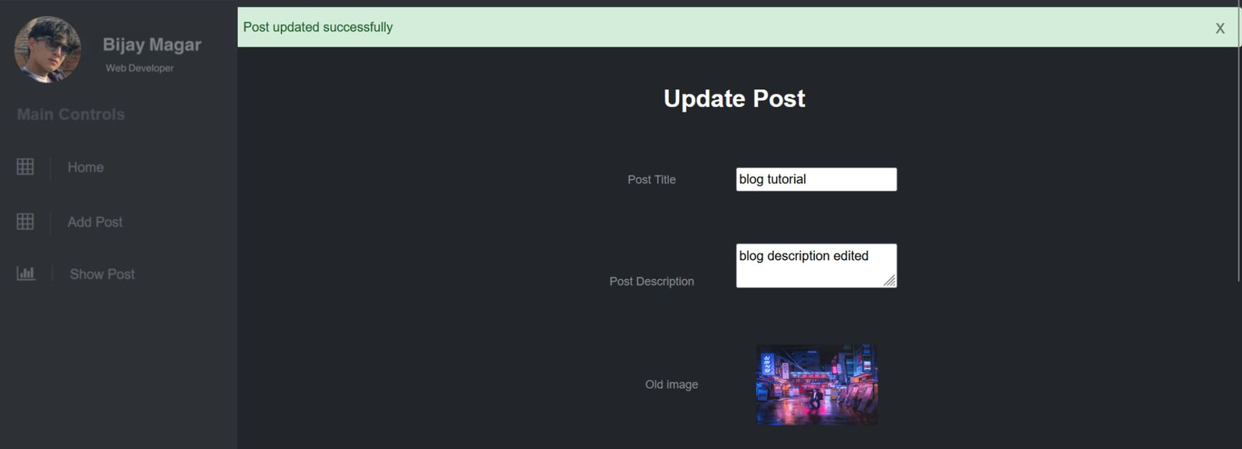

A message confirming update will appear on the top.

The admin can also delete the posts by clicking on the Delete button.

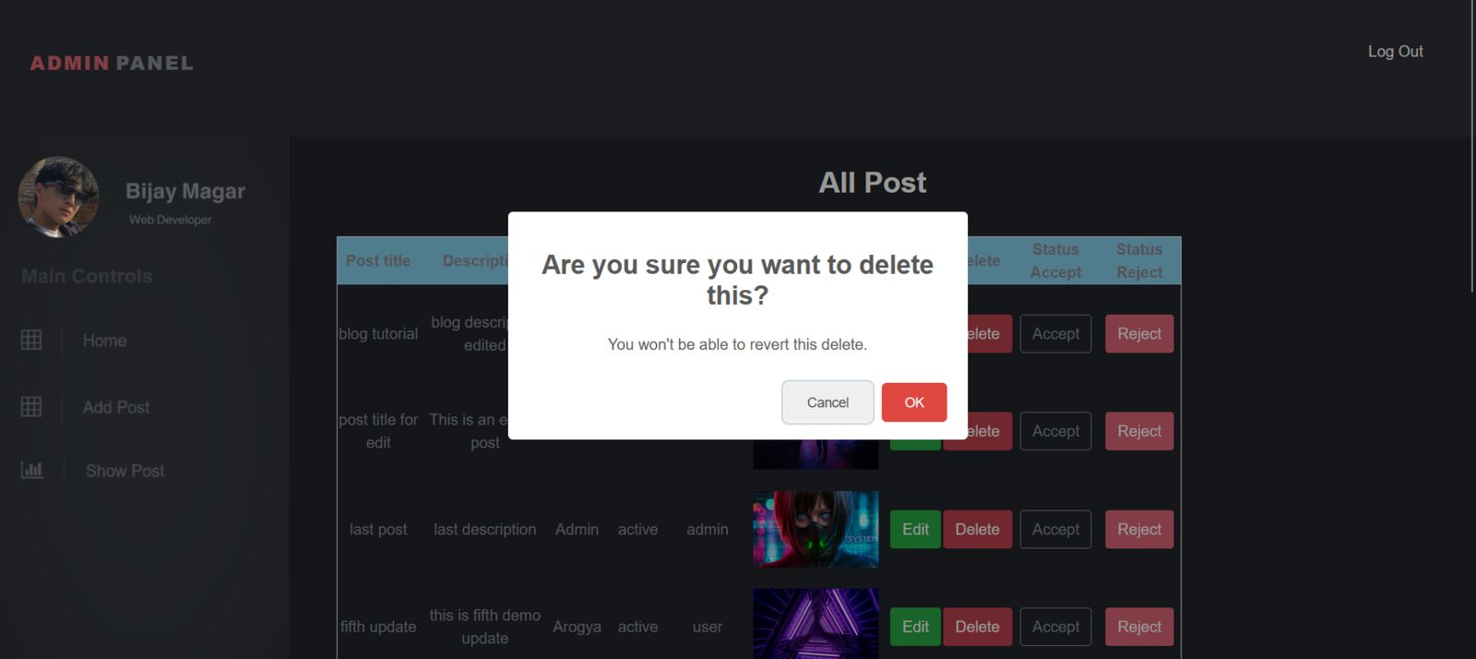

A delete confirmation message will appear if admin clicks Delete. If admin clicks OK, the post will be deleted.

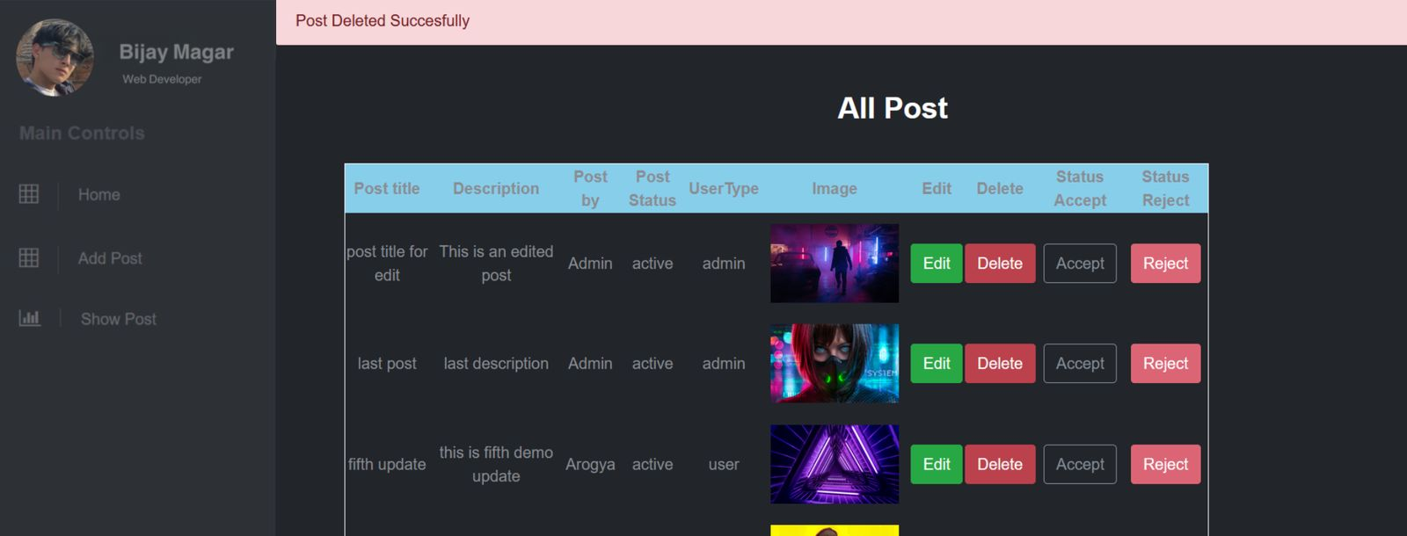

A message confirming delete will appear on the top.

The admin also has the privilege to approve a user’s post. The admin can accept or reject a post by clicking on the Accept or Reject button respectively.

Whenever a user adds a new post, its Post Status is set on pending, which means it has yet to be approved by admin.

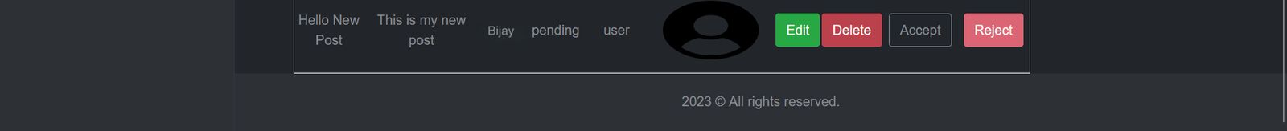

When admin accepts a user’s post, the Post Status will be changed to ‘active’ and the posts whose status are active, they will appear on the user’s home page at the Blog Posts section.





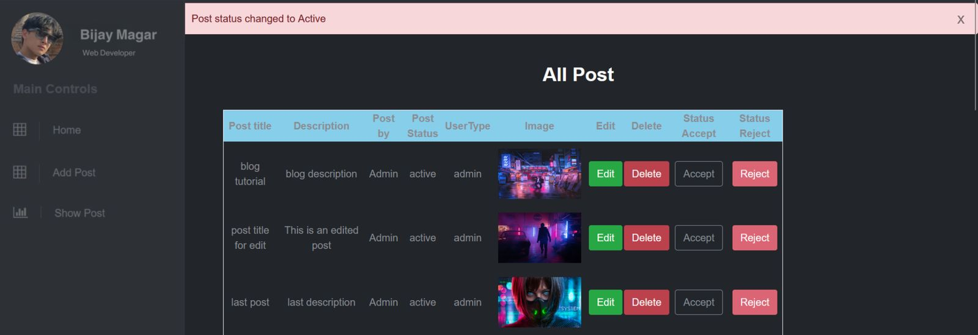

A message showing ‘Post status changed to Active’ will appear on top.

If admin rejects a post, its status will be changed to ‘rejected’ and that post will not appear on the user home page.



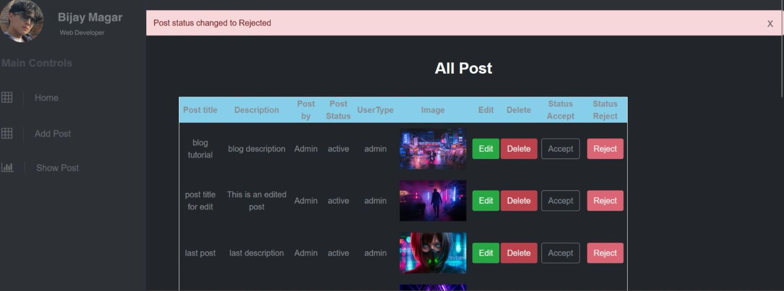  
A message showing ‘Post Status changed to Rejected’ will appear on top.

Log Out



Admin can log out using the log out button on the top right.